Overview

Peninsula Clean Energy (PCE), Silicon Valley Clean Energy (SVCE), and East Bay Community Energy (EBCE) provide recommended amendment language to the 2022 Title 24 Part 11 California Green Building Standards Code (CALGreen) sections covering Electric Vehicle (EV) Charging Infrastructure. The code intends to reach beyond the EV charging infrastructure requirements in the 2022 CALGreen. Additions are underlined, deletions are stricken through,.

These amendments are meant to be adopted in lieu of EV charging infrastructure requirements within a local zoning code. Please visit BayAreaReachCodes.Org to review related information.

Version Date | Summary of Updates
May 11, 2022 | 1st draft
July 8, 2022 | 1. Updated multifamily new construction requirements to have a high-power option of 15% EVCS and 85% Low Power Level 2 EV Ready.  2. Consolidated affordable housing requirements, including an exemption for $400 customer-side cost per space  3. Added requirements to convert Level 1 Capable spaces to Level 1 Ready spaces for Existing Buildings for applicable occupancies.
September 2022 | 1. Revised CALGreen outline headings and definitions to match July code release  2. Revisions that clarify application of code to existing buildings and ADUs  3. Note clarifying that multifamily EV spaces are 100% of either parking spaces or dwelling units, whichever is less, to account for designs with decoupled and/or unassigned parking.  4. Note clarifying that calculation for spaces shall be rounded up to the nearest whole number.
October 2022 | 1. Clarified that projects seeking exception #3 in Section 4.106.4 must still meet the state CALGreen minimum requirements.

October 2022 Updates in tracked changes
For jurisdictions that have used the September version of the model code, the substantive changes are pasted in below as tracked changes in red to enable jurisdictions to accommodate the October updates into the jurisdiction draft.

(Section 4.106.4 Exception #3)
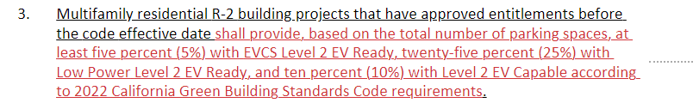

September 2022 Updates in tracked changes.
For jurisdictions that have already began using the July version of the model code, the substantive changes are pasted in the boxes below as tracked changes (red, blue, or purple text) to enable jurisdictions to accommodate the September updates into the jurisdiction draft.

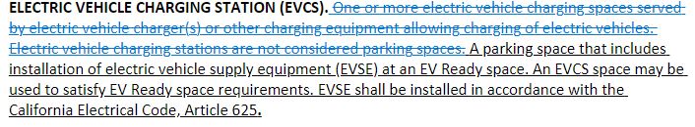

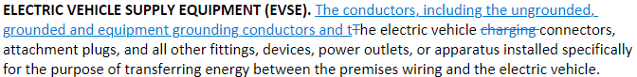

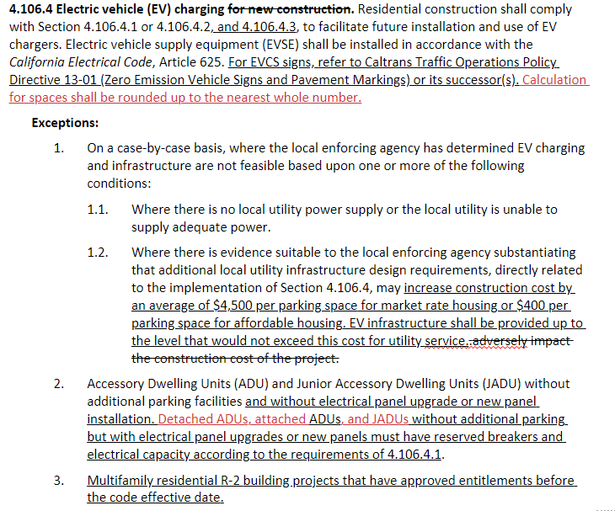

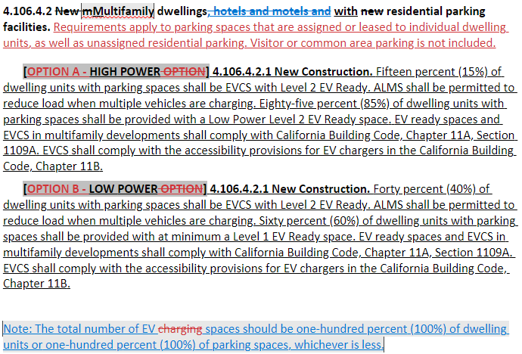

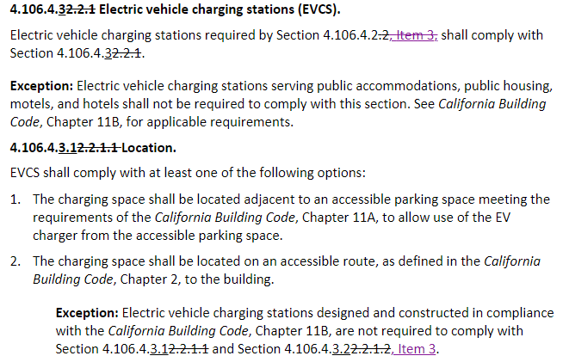

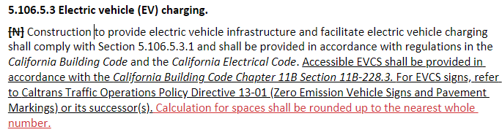

A comparison of the EV related code section outlines between the 2022 CALGreen and the proposed amendments is presented here for reader orientation. The rest of the document lays out the recommended code amendments for the Definition, Scope, Residential Mandatory Measures, and Nonresidential Mandatory Measures sections respectively.

Outline Comparison

Section Headings for Base 2022 CALGreen

RESIDENTIAL MANDATORY MEASURES
4.106.4 Electric vehicle (EV) charging for new construction.
4.106.4.1 New one- and two-family dwellings and townhouses with attached private garages.
4.106.4.1.1 Identification.

4.106.4.2 New multifamily dwellings, hotels and motels and new residential parking facilities.
4.106.4.2.1 Multifamily development projects with less than 20 dwelling units; and hotels and motels with less than 20 sleeping units or guest rooms.
4.106.4.2.2 Multifamily development projects with 20 or more dwelling units, hotels and motels with 20 or more sleeping units or guest rooms.
4.106.4.2.2.1 Electric vehicle charging stations (EVCS).
4.106.4.2.2.1.1 Location
4.106.4.2.2.1.2 Electric vehicle charging stations (EVCS) dimensions.
4.106.4.2.2.1.3 Accessible EV spaces.
4.106.4.2.3 EV space requirements.
4.106.4.2.4 Identification.
4.106.4.2.5 Electric Vehicle Ready Space Signage.

4.106.4.3 Electric vehicle charging for additions and alterations of parking facilities serving existing multifamily buildings.

NONRESIDENTIAL MANDATORY MEASURES

5.106.5.3 Electric vehicle (EV) charging.
5.106.5.3.1 EV capable spaces.
5.106.5.3.2 Electric vehicle charging stations (EVCS).
5.106.5.3.3 Use of automatic load management systems (ALMS).
5.106.5.3.4 Accessible EVCS.

5.106.5.4 Electric vehicle (EV) charging: medium-duty and heavy-duty. [N]
5.106.5.4.1 Electric vehicle charging readiness requirements for warehouses, grocery stores and retail stores with planned off-street loading spaces.

Section Headings as Recommended

RESIDENTIAL MANDATORY MEASURES
4.106.4 Electric vehicle (EV) charging
4.106.4.1 One- and two-family dwellings and town-houses with attached private garages
4.106.4.1.1 New Construction
4.106.4.1.2. Existing Building

4.106.4.2 Multifamily dwellings with residential parking facilities.
4.106.4.2.1 New Construction
4.106.4.2.2 Existing Buildings

4.106.4.3 Electric vehicle charging Stations
4.106.4.3.1 Location
4.106.4.3.2 Dimensions

4.106.4.4 Direct current fast charging stations

NONRESIDENTIAL MANDATORY MEASURES
5.106.5.3 Electric vehicle (EV) charging
5.106.5.3.1 Nonresidential Occupancy Class B Offices
5.106.5.3.1.1 New Construction
5.106.5.3.1.2 Existing Buildings

5.106.5.3.2 Hotel and Motel Occupancies – Shared Parking Facilities
5.106.5.3.2.1 New Construction
5.106.5.3.2.1 Existing Buildings

5.106.5.3.3 All Other Nonresidential Occupancies – Shared Parking Facilities
5.106.5.3.3.1 New Construction
5.106.5.3.3.2 Existing Buildings

5.106.5.3.4 Direct Current Fast Charging Stations

5.106.5.4 EV readiness.
5.106.5.4.1 Warehouses, grocery stores and retail stores with planned off-street loading spaces.

CHAPTER 2 DEFINITIONS
Section 202 DEFINITIONS
…
AFFORDABLE HOUSING. Residential buildings that entirely consist of units below market rate and whose rents or sales prices are governed by local agencies to be affordable based on area median income.

…

AUTOMATIC LOAD MANAGEMENT SYSTEM (ALMS). A control system designed to manage load across one or more electric vehicle supply equipment (EVSE), circuits, panels and to share electrical capacity and/or automatically manage power at each connection point. ALMS systems shall be designed to deliver no less than 3.3 kVa (208/240 volt, 16-ampere) to each EV Capable, EV Ready or EVCS space served by the ALMS, and meet the requirements of California Electrical Code Article 625. The connected amperage to the building site for the EV charging infrastructure shall not be lower than the required connected amperage per California Green Building Standards Code, Title 24 Part 11.

DIRECT CURRENT FAST CHARGING (DCFC). A parking space provided with electrical infrastructure that meets the following conditions:
- A minimum of 48 kVa (480 volt, 100-ampere) capacity wiring.
- Electric vehicle supply equipment (EVSE) located within three (3) feet of the parking space providing a minimum capacity of 80-ampere.

ELECTRIC VEHICLE CHARGING STATION (EVCS). One or more electric vehicle charging spaces served by electric vehicle charger(s) or other charging equipment allowing charging of electric vehicles. Electric vehicle charging stations are not considered parking spaces. A parking space that includes installation of electric vehicle supply equipment (EVSE) at an EV Ready space. An EVCS space may be used to satisfy EV Ready space requirements. EVSE shall be installed in accordance with the California Electrical Code, Article 625.

ELECTRIC VEHICLE (EV) READY SPACE. [HCD] A vehicle space which is provided with a branch circuit; any necessary raceways, both underground and/or surface mounted; to accommodate EV charging, terminating in a receptacle or a charger.

ELECTRIC VEHICLE (EV) CAPABLE SPACE. A vehicle space with electrical panel space and load capacity to support a branch circuit and necessary raceways, both underground and/or surface mounted, to support EV charging.

ELECTRIC VEHICLE SUPPLY EQUIPMENT (EVSE). The conductors, including the ungrounded, grounded and equipment grounding conductors and the electric vehicle connectors, attachment plugs, and all other fittings, devices, power outlets, or apparatus installed specifically for the purpose of transferring energy between the premises wiring and the electric vehicle.

…

LEVEL 2 ELECTRIC VEHICLE SUPPLY EQUIPMENT (EVSE). [HCD] The 208/240 Volt 40-ampere branch circuit, and the electric vehicle charging connectors, attachment plugs, and all other fittings, devices, power outlets, or apparatus installed specifically for the purpose of transferring energy between the premises wiring and the electric vehicle.

LEVEL 2 EV CAPABLE. A parking space provided with electrical infrastructure that meets the following requirements:
- Conduit that links a listed electrical panel with sufficient capacity to a junction box or receptacle located within three (3) feet of the parking space.
- The conduit shall be designed to accommodate at least 8.3 kVa (208/240 volt, 40-ampere) per parking space. Conduit shall have a minimum nominal trade size of 1 inch inside diameter and may be sized for multiple circuits as allowed by the California Electrical Code. Conduit shall be installed at a minimum in spaces that will be inaccessible after construction, either trenched underground or where penetrations to walls, floors, or other partitions would otherwise be required for future installation of branch circuits, and such additional elements deemed necessary by the Building Official. Construction documents shall indicate future completion of conduit from the panel to the parking space, via the installed inaccessible conduit.
- The electrical panel shall reserve a space for a 40-ampere overcurrent protective device space(s) for EV charging, labeled in the panel directory as “EV CAPABLE.”
- Electrical load calculations shall demonstrate that the electrical panel service capacity and electrical system, including any on-site distribution transformer(s), have sufficient capacity to simultaneously charge all EVs at all required EV spaces at a minimum of 40 amperes.
- The parking space shall contain signage with at least a 12” font adjacent to the parking space indicating the space is EV Capable.

LEVEL 1 EV READY. A parking space that is served by a complete electric circuit with the following requirements:
- A minimum of 2.2 kVa (110/120 volt, 20-ampere) capacity wiring.
- A receptacle labeled “Electric Vehicle Outlet” or electric vehicle supply equipment located within three (3) feet of the parking space. If EVSE is provided the minimum capacity of the EVSE shall be 16-ampere.
- Conduit oversized to accommodate future Level 2 EV Ready (208/240 volt, 40-ampere) at each parking space.

LEVEL 2 EV READY. A parking space that is served by a complete electric circuit with the following requirements:
- A minimum of 8.3 kVa (208/240 volt, 40-ampere) capacity wiring.
- A receptacle labeled “Electric Vehicle Outlet” or electric vehicle supply equipment located within three (3) feet of the parking space. If EVSE is provided the minimum capacity of the EVSE shall be 30-ampere.

…

LOW POWER LEVEL 2 EV READY. A parking space that is served by a complete electric circuit with the following requirements:
- A minimum of 4.1 kVA (208/240 Volt, 20-ampere) capacity wiring.
- A receptacle labeled “Electric Vehicle Outlet” or electric vehicle supply equipment located within three (3) feet of the parking space. If EVSE is provided the minimum capacity of the EVSE shall be 16-ampere.
- Conduit oversized to accommodate future Level 2 EV Ready (208/240 volt, 40-ampere) at each parking space.

LOW POWER LEVEL 2 ELECTRIC VEHICLE (EV) CHARGING RECEPTACLE. [HCD] A 208/240 Volt 20- ampere minimum branch circuit and a receptacle for use by an EV driver to charge their electric vehicle or hybrid electric vehicle.

OFF-STREET LOADING SPACES. [BSC-CG, DSA-SS] An area, other than a public street, public way, or other property (and exclusive of off-street parking spaces), permanently reserved or set aside for the loading or unloading of motor vehicles, including ways of ingress and egress and maneuvering areas. Whenever the term "loading space" is used, it shall, unless the context clearly requires otherwise, be construed as meaning off-street loading space. This excludes designated passenger loading/unloading.

CHAPTER 3 GREEN BUILDING
SECTION 301
GENERAL
301.1 Scope. … (No change to existing California amendment.)
301.1.1 Additions and alterations.
[HCD] The mandatory provisions of Chapter 4 shall be applied to additions or alterations of existing residential buildings where the addition or alteration increases the building’s conditioned area, volume, or size. The requirements shall apply only to and/or within the specific area of the addition or alteration. (No change to existing California amendment.)
The mandatory provisions of Section 4.106.4.2 may apply to additions or alterations of existing parking facilities or the addition of new parking facilities serving existing multifamily buildings. See Section 4.106.4.3 for application.
The mandatory provisions of Section 5.106.5.3 may apply to additions or alterations of existing parking facilities or the addition of new parking facilities serving existing nonresidential buildings.
NOTE: Repairs including, but not limited to, resurfacing, restriping, and repairing or maintaining existing lighting fixtures are not considered alterations for the purpose of this section.

CHAPTER 4 RESIDENTIAL MANDATORY MEASURES
DIVISION 4.1, PLANNING AND DESIGN

SECTION 4.106
SITE DEVELOPMENT
4.106.4 Electric vehicle (EV) charging for new construction. Residential construction shall comply with Section 4.106.4.1 or 4.106.4.2, and 4.106.4.3, to facilitate future installation and use of EV chargers. Electric vehicle supply equipment (EVSE) shall be installed in accordance with the California Electrical Code, Article 625. For EVCS signs, refer to Caltrans Traffic Operations Policy Directive 13-01 (Zero Emission Vehicle Signs and Pavement Markings) or its successor(s). Calculation for spaces shall be rounded up to the nearest whole number.
Exceptions:
- On a case-by-case basis, where the local enforcing agency has determined EV charging and infrastructure are not feasible based upon one or more of the following conditions:
  - Where there is no local utility power supply or the local utility is unable to supply adequate power.
  - Where there is evidence suitable to the local enforcing agency substantiating that additional local utility infrastructure design requirements, directly related to the implementation of Section 4.106.4, may increase construction cost by an average of $4,500 per parking space for market rate housing or $400 per parking space for affordable housing. EV infrastructure shall be provided up to the level that would not exceed this cost for utility service..adversely impact the construction cost of the project.
- Accessory Dwelling Units (ADU) and Junior Accessory Dwelling Units (JADU) without additional parking facilities and without electrical panel upgrade or new panel installation. Detached ADUs, attached ADUs, and JADUs without additional parking but with electrical panel upgrades or new panels must have reserved breakers and electrical capacity according to the requirements of 4.106.4.1.
- Multifamily residential R-2 building projects that have approved entitlements before the code effective date shall provide, based on the total number of parking spaces, at least five percent (5%) with EVCS Level 2 EV Ready, twenty-five percent (25%) with Low Power Level 2 EV Ready, and ten percent (10%) with Level 2 EV Capable according to 2022 California Green Building Standards Code requirements.

4.106.4.1 New oOne- and two-family dwellings and town-houses with private garages.
4.106.4.1.1 New Construction. One parking space provided shall be a Level 2 EV Ready space. If a second parking space is provided, it shall be provided with a Level 1 EV Ready space. For each dwelling unit, install a listed raceway to accommodate a dedicated 208-240-volt branch circuit. The raceway shall not be less than trade size 1 (nominal 1-inch inside diameter). The raceway shall originate at the main service or subpanel and shall terminate into a listed cabinet, box or other enclosure in close proximity to the proposed location of an EV charger. Raceways are required to be continuous at enclosed, inaccessible or concealed areas and spaces. The service panel and/or subpanel shall provide capacity to install a 40-ampere 208/240-volt minimum dedicated branch circuit and space(s) reserved to permit installation of a branch circuit overcurrent protective device.
Exception: A raceway is not required if a minimum 40-ampere 208/240-volt dedicated EV branch circuit is installed in close proximity to the proposed location of an EV charger at the time of original construction in accordance with the California Electrical Code.
4.106.4.1.1 Identification. The service panel or subpanel circuit directory shall identify the overcurrent protective device space(s) reserved for future EV charging as “EV CAPABLE”. The raceway termination location shall be permanently and visibly marked as “EV CAPABLE”.

4.106.4.1.2. Existing Building. Parking additions or electrical panel upgrades must have reserved breaker spaces and electrical capacity according to the requirements of 4.106.4.1.1.

…

4.106.4.2 New mMultifamily dwellings, hotels and motels and with new residential parking facilities. Requirements apply to parking spaces that are assigned or leased to individual dwelling units, as well as unassigned residential parking. Visitor or common area parking is not included.
[OPTION A - HIGH POWER] 4.106.4.2.1 New Construction. Fifteen percent (15%) of dwelling units with parking spaces shall be EVCS with Level 2 EV Ready. ALMS shall be permitted to reduce load when multiple vehicles are charging. Eighty-five percent (85%) of dwelling units with parking spaces shall be provided with a Low Power Level 2 EV Ready space. EV ready spaces and EVCS in multifamily developments shall comply with California Building Code, Chapter 11A, Section 1109A. EVCS shall comply with the accessibility provisions for EV chargers in the California Building Code, Chapter 11B.
[OPTION B - LOW POWER] 4.106.4.2.1 New Construction. Forty percent (40%) of dwelling units with parking spaces shall be EVCS with Level 2 EV Ready. ALMS shall be permitted to reduce load when multiple vehicles are charging. Sixty percent (60%) of dwelling units with parking spaces shall be provided with at minimum a Level 1 EV Ready space. EV ready spaces and EVCS in multifamily developments shall comply with California Building Code, Chapter 11A, Section 1109A. EVCS shall comply with the accessibility provisions for EV chargers in the California Building Code, Chapter 11B.

Note: The total number of EV spaces should be one-hundred percent (100%) of dwelling units or one-hundred percent (100%) of parking spaces, whichever is less.
When parking is provided, parking spaces for new multifamily dwellings, hotels and motels shall meet the requirements of Sections 4.106.4.2.1 and 4.106.4.2.2. Calculations for spaces shall be rounded up to the nearest whole number. A parking space served by electric vehicle supply equipment or designed as a future EV charging space shall count as at least one standard automobile parking space only for the purpose of complying with any applicable minimum parking space requirements established by a local jurisdiction. See Vehicle Code Section 22511.2 for further details.
4.106.4.2.1 Multifamily development projects with less than 20 dwelling units; and hotels and motels with less than 20 sleeping units or guest rooms.
The number of dwelling units, sleeping units or guest rooms shall be based on all buildings on a project site subject to this section.
- EV Capable. Ten (10) percent of the total number of parking spaces on a building site, provided for all types of parking facilities, shall be electric vehicle charging spaces (EV spaces) capable of supporting future Level 2 EVSE. Electrical load calculations shall demonstrate that the electrical panel service capacity and electrical system, including any on-site distribution transformer(s), have sufficient capacity to simultaneously charge all EVs at all required EV spaces at a minimum of 40 amperes.
The service panel or subpanel circuit directory shall identify the overcurrent protective device space(s) reserved for future EV charging purposes as “EV CAPABLE” in accordance with the California Electrical Code.
Exceptions:
- When EV chargers (Level 2 EVSE) are installed in a number equal to or greater than the required number of EV capable spaces.
- When EV chargers (Level 2 EVSE) are installed in a number less than the required number of EV capable spaces, the number of EV capable spaces required may be reduced by a number equal to the number of EV chargers installed.
Notes:
    - Construction documents are intended to demonstrate the project’s capability and capacity for facilitating future EV charging.
    - There is no requirement for EV spaces to be constructed or available until receptacles for EV charging or EV chargers are installed for use.
- EV Ready. Twenty-five (25) percent of the total number of parking spaces shall be equipped with low power Level 2 EV charging receptacles. For multifamily parking facilities, no more than one receptacle is required per dwelling unit when more than one parking space is provided for use by a single dwelling unit.
Exception: Areas of parking facilities served by parking lifts.
4.106.4.2.2 Multifamily development projects with 20 or more dwelling units, hotels and motels with 20 or more sleeping units or guest rooms.
The number of dwelling units, sleeping units or guest rooms shall be based on all buildings on a project site subject to this section.
- EV Capable. Ten (10) percent of the total number of parking spaces on a building site, provided for all types of parking facilities, shall be electric vehicle charging spaces (EV spaces) capable of supporting future Level 2 EVSE. Electrical load calculations shall demonstrate that the electrical panel service capacity and electrical system, including any on-site distribution transformer(s), have sufficient capacity to simultaneously charge all EVs at all required EV spaces at a minimum of 40 amperes.
The service panel or subpanel circuit directory shall identify the overcurrent protective device space(s) reserved for future EV charging purposes as “EV CAPABLE” in accordance with the California Electrical Code.
Exception: When EV chargers (Level 2 EVSE) are installed in a number greater than five (5) percent of parking spaces required by Section 4.106.4.2.2, Item 3, the number of EV capable spaces required may be reduced by a number equal to the number of EV chargers installed over the five (5) percent required.
Notes:
- Construction documents shall show locations of future EV spaces.
- There is no requirement for EV spaces to be constructed or available until receptacles for EV charging or EV chargers are installed for use.
- EV Ready. Twenty-five (25) percent of the total number of parking spaces shall be equipped with low power Level 2 EV charging receptacles. For multifamily parking facilities, no more than one receptacle is required per dwelling unit when more than one parking space is provided for use by a single dwelling unit.
Exception: Areas of parking facilities served by parking lifts.
- EV Chargers. Five (5) percent of the total number of parking spaces shall be equipped with Level 2 EVSE. Where common use parking is provided, at least one EV charger shall be located in the common use parking area and shall be available for use by all residents or guests.
When low power Level 2 EV charging receptacles or Level 2 EVSE are installed beyond the minimum required, an automatic load management system (ALMS) may be used to reduce the maximum required electrical capacity to each space served by the ALMS. The electrical system and any on-site distribution transformers shall have sufficient capacity to deliver at least 3.3 kW simultaneously to each EV charging station (EVCS) served by the ALMS. The branch circuit shall have a minimum capacity of 40 amperes and installed EVSE shall have a capacity of not less than 30 amperes. ALMS shall not be used to reduce the minimum required electrical capacity to the required EV capable spaces.
4.106.4.2.2 Existing Buildings.
- When new parking facilities are added, or electrical systems or lighting of existing parking facilities are added or altered and the work requires a building permit, ten percent (10%) of the total number of parking spaces added or altered shall be EVCS. Any existing EV Capable spaces on the building property required by the locally adopted codes at the time of building permit shall be upgraded to a minimum of Level 1 EV Ready. Upgrades shall be required at currently designated vehicle parking spaces. Upgrades shall be required for remaining parking spaces after meeting the accessibility requirements of California Building Code Chapters 11A and 11B.
- When new parking facilities are added and ALMS is installed, the ALMS system must be designed to deliver no less than 2.2 kVa (110/120 volt, 20-ampere).

4.106.4.32.2.1 Electric vehicle charging stations (EVCS).
Electric vehicle charging stations required by Section 4.106.4.2.2, Item 3, shall comply with Section 4.106.4.32.2.1.
Exception: Electric vehicle charging stations serving public accommodations, public housing, motels, and hotels shall not be required to comply with this section. See California Building Code, Chapter 11B, for applicable requirements.
4.106.4.3.12.2.1.1 Location.
EVCS shall comply with at least one of the following options:
- The charging space shall be located adjacent to an accessible parking space meeting the requirements of the California Building Code, Chapter 11A, to allow use of the EV charger from the accessible parking space.
- The charging space shall be located on an accessible route, as defined in the California Building Code, Chapter 2, to the building.
Exception: Electric vehicle charging stations designed and constructed in compliance with the California Building Code, Chapter 11B, are not required to comply with Section 4.106.4.3.12.2.1.1 and Section 4.106.4.3.22.2.1.2, Item 3.
4.106.4.3.22.2.1.2 Electric vehicle charging stations (EVCS) dDimensions.
The charging spaces shall be designed to comply with the following:
- The minimum length of each EV space shall be 18 feet (5486 mm).
- The minimum width of each EV space shall be 9 feet (2743 mm).
- One in every 25 charging spaces, but not less than one, shall also have an 8- foot (2438 mm) wide minimum aisle. A 5-foot (1524 mm) wide minimum aisle shall be permitted provided the minimum width of the EV space is 12 feet (3658 mm).
  - Surface slope for this EV space and the aisle shall not exceed 1 unit vertical in 48 units horizontal (2.083 percent slope) in any direction.
Exception: Where the City’s Municipal or Zoning Code permits parking space dimensions that are less than the minimum requirements stated in this section 4.106.4.3.2, and the compliance with which would be infeasible due to particular circumstances of a project, an exception may be granted while remaining in compliance with California Building Code Section Table 11B-228.3.2.1 and 11B-812, as applicable.

4.106.4.2.2.1.3 Accessible EV spaces. In addition to the requirements in Sections 4.106.4.2.2.1.1 and 4.106.4.2.2.1.2, all EVSE, when installed, shall comply with the accessibility provisions for EV chargers in the California Building Code, Chapter 11B. EV ready spaces and EVCS in multifamily developments shall comply with California Building Code, Chapter 11A, Section 1109A.

4.106.4.4 Direct current fast charging stations. One DCFC may be substituted for up to five (5) EVCS to meet the requirements of 4.106.4.1 and 4.106.4.2. Where ALMS serve DCFC stations, the power demand from the DCFC shall be prioritized above Level 1 and Level 2 spaces.

4.106.4.2.3 EV space requirements.
- Single EV space required. Install a listed raceway capable of accommodating a 208/240-volt dedicated branch circuit. The raceway shall not be less than trade size 1 (nominal 1-inch inside diameter). The raceway shall originate at the main service or subpanel and shall terminate into a listed cabinet, box or enclosure in close proximity to the location or the proposed location of the EV space. Construction documents shall identify the raceway termination point, receptacle or charger location, as applicable. The service panel and/or subpanel shall have a 40-ampere minimum dedicated branch circuit, including branch circuit overcurrent protective device installed, or space(s) reserved to permit installation of a branch circuit overcurrent protective device.
Exception: A raceway is not required if a minimum 40-ampere 208/240-volt dedicated EV branch circuit is installed in close proximity to the location or the proposed location of the EV space, at the time of original construction in accordance with the California Electrical Code.
- Multiple EV spaces required. Construction documents shall indicate the raceway termination point and the location of installed or future EV spaces, receptacles, or EV chargers. Construction documents shall also provide information on amperage of installed or future receptacles or EVSE, raceway method(s), wiring schematics and electrical load calculations. Plan design shall be based upon a 40-ampere minimum branch circuit. Required raceways and related components that are planned to be installed underground, enclosed, inaccessible or in concealed areas and spaces shall be installed at the time of original construction.
Exception: A raceway is not required if a minimum 40-ampere 208/240-volt dedicated EV branch circuit is installed in close proximity to the location or the proposed location of the EV space at the time of original construction in accordance with the California Electrical Code.
4.106.4.2.4 Identification.
The service panel or subpanel circuit directory shall identify the overcurrent protective device space(s) reserved for future EV charging purposes as “EV CAPABLE” in accordance with the California Electrical Code.
4.106.4.2.5 Electric Vehicle Ready Space Signage.
Electric vehicle ready spaces shall be identified by signage or pavement markings, in compliance with Caltrans Traffic Operations Policy Directive 13-01 (Zero Emission Vehicle Signs and Pavement Markings) or its successor(s).
4.106.4.3 Electric vehicle charging for additions and alterations of parking facilities serving existing multifamily buildings.
When new parking facilities are added, or electrical systems or lighting of existing parking facilities are added or altered and the work requires a building permit, ten (10) percent of the total number of parking spaces added or altered, shall be electric vehicle charging spaces (EV spaces) capable of supporting future Level 2 EVSE.
Notes:
- Construction documents are intended to demonstrate the project’s capability and capacity for facilitating future EV charging.
- There is no requirement for EV spaces to be constructed or available until EV chargers are installed for use.

CHAPTER 5 NONRESIDENTIAL MANDATORY MEASURES

SECTION 5.106
SITE DEVELOPMENT

5.106.5.3 Electric vehicle (EV) charging.
[N] Construction to provide electric vehicle infrastructure and facilitate electric vehicle charging shall comply with Section 5.106.5.3.1 and shall be provided in accordance with regulations in the California Building Code and the California Electrical Code. Accessible EVCS shall be provided in accordance with the California Building Code Chapter 11B Section 11B-228.3. For EVCS signs, refer to Caltrans Traffic Operations Policy Directive 13-01 (Zero Emission Vehicle Signs and Pavement Markings) or its successor(s). Calculation for spaces shall be rounded up to the nearest whole number.

Exceptions:
1. On a case-by-case basis where the local enforcing agency has determined compliance with this section is not feasible based upon one of the following conditions:
a. Where there is no local utility power supply.
b. Where the local utility is unable to supply adequate power.
c. Where there is evidence suitable to the local enforcement agency substantiating that additional local utility infrastructure design requirements, directly related to the implementation of Section 5.106.5.3, may increase construction cost by an average of $4,500 per parking space. EV infrastructure shall be provided up to the level that would not exceed this cost for utility service. adversely impact the construction cost of the project.

2. Parking spaces accessible only by automated mechanical car parking systems are not required to comply with this code section.

5.106.5.3.1 Nonresidential Occupancy Class B Offices – Shared Parking Space.
5.106.5.3.1.1 New Construction. Twenty percent (20%) of parking spaces shall be EVCS with Level 2 EV Ready. ALMS shall be permitted to reduce load when multiple vehicles are charging. Thirty percent (30%) of parking spaces provided shall be Level 2 EV Capable.

5.106.5.3.1.2 Existing Buildings. When new parking facilities are added, or electrical systems or lighting of existing parking facilities are added or altered and the work requires a building permit, ten percent (10%) of the total number of parking spaces added or altered shall be EVCS with Level 2 EV Ready. Any existing EV Capable spaces on the building property required by the locally adopted codes at the time of building permit shall be upgraded to a minimum of Level 1 EV Ready. Upgrades shall be required at currently designated vehicle parking spaces. Upgrades shall be required for remaining parking spaces after meeting the accessibility requirements of California Building Code Chapters 11A and 11B.
5.106.5.3.1 EV capable spaces.
[N] EV capable spaces shall be provided in accordance with Table 5.106.5.3.1 and the following requirements:
1. Raceways complying with the California Electrical Code and no less than 1-inch (25 mm) diameter shall be provided and shall originate at a service panel or a subpanel(s) serving the area, and shall terminate in close proximity to the proposed location of the EV capable space and into a suitable listed cabinet, box, enclosure or equivalent. A common raceway may be used to serve multiple EV capable spaces.
2. A service panel or subpanel(s) shall be provided with panel space and electrical load capacity for a dedicated 208/240 volts, 40-ampere minimum branch circuits for each EV capable space, with delivery of 30-ampere minimum to an installed EVSE at each EVCS.
3 The electrical system and any on-site distribution transformers shall have sufficient capacity to supply full rated amperage at each EV capable space.

4.The service panel or subpanel circuit directory shall identify the reserved overcurrent protective device space(s) as “EV CAPABLE”. The raceway termination location shall be permanently and visibly marked as “EV CAPABLE”.

Note: A parking space served by electric vehicle supply equipment or designed as a future EV charging space shall count as at least one standard automobile parking space only for the purpose of complying with any applicable minimum parking space requirements established by an enforcement agency. See Vehicle Code Section 22511.2 for further details.

TABLE 5.106.5.3.1
TOTAL NUMBER OF  ACTUAL PARKING SPACES | NUMBER OF REQUIRED EV CAPABLE SPACES | NUMBER OF  EVCS  (EV CAPABLE SPACES PROVIDED WITH EVSE) ²
0-9 | 0 | 0
10-25 | 4 | 0
26-50 | 8 | 2
51-75 | 13 | 3
76-100 | 17 | 4
101-150 | 25 | 6
151-200 | 35 | 9
201 and over | 20 percent of total¹ | 25 percent of EV capable spaces ¹
1. Calculation for spaces shall be rounded up to the nearest whole number.
2. The number of required EVCS (EV capable spaces provided with EVSE) in column 3 count toward the total number of required EV capable spaces shown in column 2.

…

5.106.5.3.2 Electric vehicle charging stations (EVCS).
EV capable spaces shall be provided with EVSE to create EVCS in the number indicated in Table 5.106.5.3.1. The EVCS required by Table 5.106.5.3.1 may be provided with EVSE in any combination of Level 2 and Direct Current Fast Charging (DCFC), except that at least one Level 2 EVSE shall be provided.

One EV charger with multiple connectors capable of charging multiple EVs simultaneously shall be permitted if the electrical load capacity required by Section 5.106.5.3.1 for each EV capable space is accumulatively supplied to the EV charger.

The installation of each DCFC EVSE shall be permitted to reduce the minimum number of required EV capable spaces without EVSE by five and reduce proportionally the required electrical load capacity to the service panel or subpanel.

5.106.5.3.2 Hotel and Motel Occupancies – Shared Parking Facilities.
5.106.5.3.2.1 New Construction. Five percent (5%) of parking spaces provided shall be EVCS with Level 2 EV Ready. ALMS shall be permitted to reduce load when multiple vehicles are charging. Twenty-five percent (25%) of parking spaces provided shall be Low Power Level 2 EV Ready space. Ten percent (10%) of parking spaces provided shall be Level 2 EV Capable.

5.106.5.3.2.2 Existing Buildings. When new parking facilities are added, or electrical systems or lighting of existing parking facilities are added or altered and the work requires a building permit, ten percent (10%) of the total number of parking spaces added or altered shall be EVCS with Level 2 EV Ready. Any existing EV Capable spaces on the building property required by the locally adopted codes at the time of building permit shall be upgraded to a minimum of Level 1 EV Ready. Upgrades shall be required at currently designated vehicle parking spaces. Upgrades shall be required for remaining parking spaces after meeting the accessibility requirements of California Building Code Chapters 11A and 11B.

5.106.5.3.3 All Other Nonresidential Occupancies – Shared Parking Facilities.
5.106.5.3.3.1 New Construction. Ten percent (10%) of parking spaces provided shall be EVCS with Level 2 EV Ready. ALMS shall be permitted to reduce load when multiple vehicles are charging. Ten percent (10%) of parking spaces provided shall be Level 2 EV Capable.

5.106.5.3.3.2 Existing Buildings. When new parking facilities are added, or electrical systems or lighting of existing parking facilities are added or altered and the work requires a building permit, ten percent (10%) of the total number of parking spaces added or altered shall be EVCS with Level 2 EV Ready. Any existing EV Capable spaces on the building property required by the locally adopted codes at the time of building permit shall be upgraded to a minimum of Level 1 EV Ready. Upgrades shall be required at currently designated vehicle parking spaces. Upgrades shall be required for remaining parking spaces after meeting the accessibility requirements of California Building Code Chapters 11A and 11B.

5.106.5.3.3 Use of automatic load management systems (ALMS).
ALMS shall be permitted for EVCS. When ALMS is installed, the required electrical load capacity specified in Section 5.106.5.3.1 for each EVCS may be reduced when serviced by an EVSE controlled by an ALMS. Each EVSE controlled by an ALMS shall deliver a minimum 30 amperes to an EV when charging one vehicle and shall deliver a minimum 3.3 kW while simultaneously charging multiple EVs.

5.106.5.3.4 Direct current fast charging stations. One DCFC may be substituted for up to five (5) EVCS to meet the requirements of 5.106.5.3.1, 5.106.5.3.2, and 5.106.5.3.3. Where ALMS serve DCFC stations, the power demand from the DCFC shall be prioritized above Level 1 and Level 2 spaces.

5.106.5.3.4 Accessible EVCS.
When EVSE is installed, accessible EVCS shall be provided in accordance with the California Building Code Chapter 11B Section 11B-228.3.
Note: For EVCS signs, refer to Caltrans Traffic Operations Policy Directive 13-01 (Zero Emission Vehicle Signs and Pavement Markings) or its successor(s).

5.106.5.4 Electric vehicle (EV) charging readiness: medium-duty and heavy-duty. [N]
Construction shall comply with Section 5.106.5.4.1 to facilitate future installation of electric vehicle supply equipment (EVSE). Construction for warehouses, grocery stores and retail stores with planned off-street loading spaces shall also comply with Section 5.106.5.4.1 for future installation of medium- and heavy-duty EVSE. Accessible EVCS shall be provided in accordance with the California Building Code Chapter 11B Section 11B-228.3. For EVCS signs, refer to Caltrans Traffic Operations Policy Directive 13-01 (Zero Emission Vehicle Signs and Pavement Markings) or its successor(s).

Exceptions:
1. On a case-by-case basis where the local enforcing agency has determined compliance with this section is not feasible based upon one of the following conditions:
a. Where there is no local utility power supply.
b. Where the local utility is unable to supply adequate power.
c. Where there is evidence suitable to the local enforcing agency substantiating that additional local utility infrastructure design requirements, directly related to the implementation of Section 5.106.5.3, may increase construction cost by an average of $4,500 per parking space. EV infrastructure shall be provided up to the level that would not exceed this cost for utility service. adversely impact the construction cost of the project.

When EVCS(s) are installed, it shall be in accordance with the California Building Code, the California Electrical Code as follows:

5.106.5.4.1 Electric vehicle charging readiness requirements for wWarehouses, grocery stores and retail stores with planned off-street loading spaces.
[N] In order to avoid future demolition when adding EV supply and distribution equipment, spare raceway(s) or busway(s) and adequate capacity for transformer(s), service panel(s) or subpanel(s) shall be installed at the time of construction in accordance with the California Electrical Code. Construction plans and specifications shall include, but are not limited to, the following:
- The transformer, main service equipment and subpanels shall meet the minimum power requirement in Table 5.106.5.4.1 to accommodate the dedicated branch circuits for the future installation of EVSE.
- The construction documents shall indicate one or more location(s) convenient to the planned off-street loading space(s) reserved for medium- and heavy-duty ZEV charging cabinets and charging dispensers, and a pathway reserved for routing of conduit from the termination of the raceway(s) or busway(s) to the charging cabinet(s) and dispenser(s), as shown in Table 5.106.5.4.1.
- Raceway(s) or busway(s) originating at a main service panel or a subpanel(s) serving the area where potential future medium- and heavy-duty EVSE will be located and shall terminate in close proximity to the potential future location of the charging equipment for medium- and heavy-duty vehicles.
- The raceway(s) or busway(s) shall be of sufficient size to carry the minimum additional system load to the future location of the charging for medium- and heavy-duty EVs as shown in Table 5.106.5.4.1.
TABLE 5.106.5.4.1, Raceway Conduit and Panel power Requirements for Medium-and-Heavy-Duty EVSE [N]
Building type | Building Size  (sq. ft.) | Number of Off-street loading spaces | Additional capacity Required (kVa) for Raceway & Busway and Transformer & Panel
Grocery | 10,000 to 90,000 | 1 or 2 | 200
Grocery | Greater than 90,000 | 3 or Greater | 400
Grocery | Greater than 90,000 | 1 or Greater | 400
Retail | 10,000 to 135,000 | 1 or 2 | 200
Retail | 10,000 to 135,000 | 3 or Greater | 400
Retail | Greater than 135,000 | 1 or Greater | 400
Warehouse  Warehouse  Warehouse | 20,000 to 256,000  20,000 to 256,000 | 1 or 2 | 200
 |  | 3 or Greater | 400
 | Greater than 256,000 | 1 or Greater | 400

